**Problem # 1**

**Depth 4**

TreeSearch----------------------------------

BreadthFirstTreeSearch: (cost=568.0, expansions=39) Timisoara Arad Sibiu Fagaras Bucharest

UniformCostTreeSearch: (cost=536.0, expansions=93) Timisoara Arad Sibiu Rimnicu Pitesti Bucharest

DepthFirstTreeSearch: (cost=568.0, expansions=4) Timisoara Arad Sibiu Fagaras Bucharest

GreedyBestFirstTreeSearch: (cost=615.0, expansions=6) Timisoara Lugoj Mehadia Drobeta Craiova Pitesti Bucharest

DepthLimitedTreeSearch: (cost=568.0, expansions=9) Timisoara Arad Sibiu Fagaras Bucharest

IterativeDeepeningTreeSearch: (cost=568.0, expansions=13) Timisoara Arad Sibiu Fagaras Bucharest

AStarTreeSearch: (cost=536.0, expansions=11) Timisoara Arad Sibiu Rimnicu Pitesti Bucharest

GraphSearch----------------------------------

BreadthFirstGraphSearch: (cost=568.0, expansions=12) Timisoara Arad Sibiu Fagaras Bucharest

UniformCostGraphSearch: (cost=536.0, expansions=12) Timisoara Arad Sibiu Rimnicu Pitesti Bucharest

DepthFirstGraphSearch: (cost=568.0, expansions=6) Timisoara Arad Sibiu Fagaras Bucharest

GreedyBestFirstGraphSearch: (cost=615.0, expansions=6) Timisoara Lugoj Mehadia Drobeta Craiova Pitesti Bucharest

DepthLimitedGraphSearch: (cost=568.0, expansions=6) Timisoara Arad Sibiu Fagaras Bucharest

IterativeDeepeningGraphSearch: (cost=568.0, expansions=7) Timisoara Arad Sibiu Fagaras Bucharest

AStarGraphSearch: (cost=536.0, expansions=10) Timisoara Arad Sibiu Rimnicu Pitesti Bucharest

**Depth 5**

TreeSearch----------------------------------

BreadthFirstTreeSearch: (cost=568.0, expansions=39) Timisoara Arad Sibiu Fagaras Bucharest

UniformCostTreeSearch: (cost=536.0, expansions=93) Timisoara Arad Sibiu Rimnicu Pitesti Bucharest

DepthFirstTreeSearch: (cost=568.0, expansions=4) Timisoara Arad Sibiu Fagaras Bucharest

GreedyBestFirstTreeSearch: (cost=615.0, expansions=6) Timisoara Lugoj Mehadia Drobeta Craiova Pitesti Bucharest

DepthLimitedTreeSearch: null

IterativeDeepeningTreeSearch: (cost=568.0, expansions=13) Timisoara Arad Sibiu Fagaras Bucharest

AStarTreeSearch: (cost=536.0, expansions=11) Timisoara Arad Sibiu Rimnicu Pitesti Bucharest

GraphSearch----------------------------------

BreadthFirstGraphSearch: (cost=568.0, expansions=12) Timisoara Arad Sibiu Fagaras Bucharest

UniformCostGraphSearch: (cost=536.0, expansions=12) Timisoara Arad Sibiu Rimnicu Pitesti Bucharest

DepthFirstGraphSearch: (cost=568.0, expansions=6) Timisoara Arad Sibiu Fagaras Bucharest

GreedyBestFirstGraphSearch: (cost=615.0, expansions=6) Timisoara Lugoj Mehadia Drobeta Craiova Pitesti Bucharest

DepthLimitedGraphSearch: null

IterativeDeepeningGraphSearch: (cost=568.0, expansions=6) Timisoara Arad Sibiu Fagaras Bucharest

AStarGraphSearch: (cost=536.0, expansions=10) Timisoara Arad Sibiu Rimnicu Pitesti Bucharest

**Depth 6**

TreeSearch----------------------------------

BreadthFirstTreeSearch: (cost=568.0, expansions=39) Timisoara Arad Sibiu Fagaras Bucharest

UniformCostTreeSearch: (cost=536.0, expansions=93) Timisoara Arad Sibiu Rimnicu Pitesti Bucharest

DepthFirstTreeSearch: (cost=568.0, expansions=4) Timisoara Arad Sibiu Fagaras Bucharest

GreedyBestFirstTreeSearch: (cost=615.0, expansions=6) Timisoara Lugoj Mehadia Drobeta Craiova Pitesti Bucharest

DepthLimitedTreeSearch: (cost=615.0, expansions=7) Timisoara Lugoj Mehadia Drobeta Craiova Pitesti Bucharest

IterativeDeepeningTreeSearch: (cost=568.0, expansions=12) Timisoara Arad Sibiu Fagaras Bucharest

AStarTreeSearch: (cost=536.0, expansions=11) Timisoara Arad Sibiu Rimnicu Pitesti Bucharest

GraphSearch----------------------------------

BreadthFirstGraphSearch: (cost=568.0, expansions=12) Timisoara Arad Sibiu Fagaras Bucharest

UniformCostGraphSearch: (cost=536.0, expansions=12) Timisoara Arad Sibiu Rimnicu Pitesti Bucharest

DepthFirstGraphSearch: (cost=615.0, expansions=6) Timisoara Lugoj Mehadia Drobeta Craiova Pitesti Bucharest

GreedyBestFirstGraphSearch: (cost=615.0, expansions=6) Timisoara Lugoj Mehadia Drobeta Craiova Pitesti Bucharest

DepthLimitedGraphSearch: (cost=615.0, expansions=6) Timisoara Lugoj Mehadia Drobeta Craiova Pitesti Bucharest

IterativeDeepeningGraphSearch: (cost=568.0, expansions=10) Timisoara Arad Sibiu Fagaras Bucharest

AStarGraphSearch: (cost=536.0, expansions=10) Timisoara Arad Sibiu Rimnicu Pitesti Bucharest

**Problem # 2**

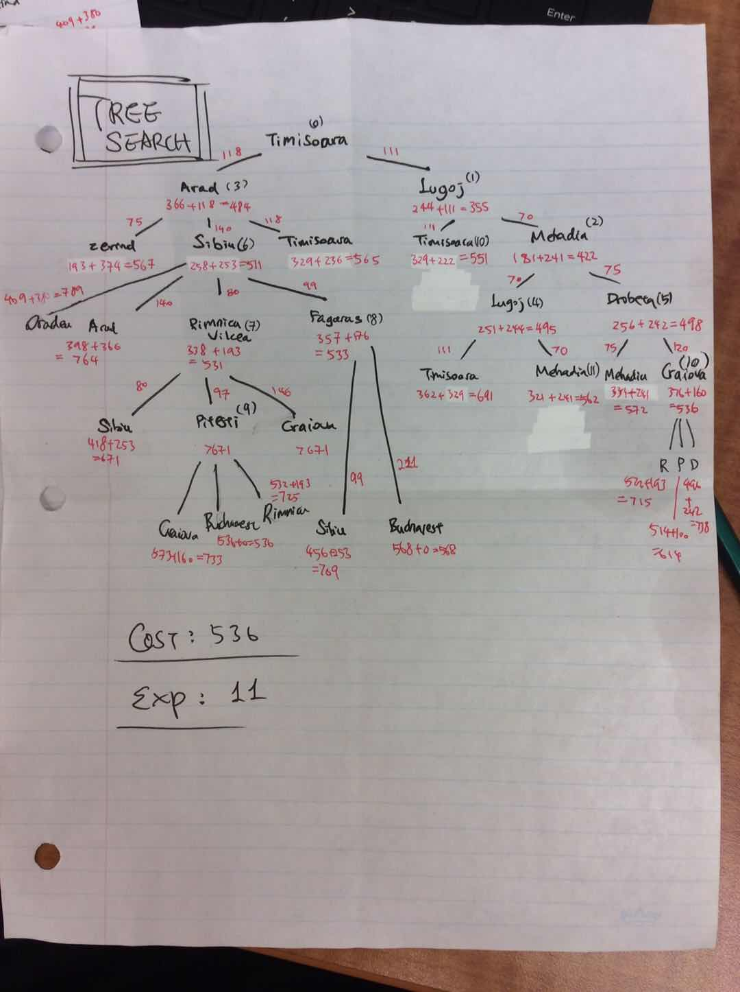

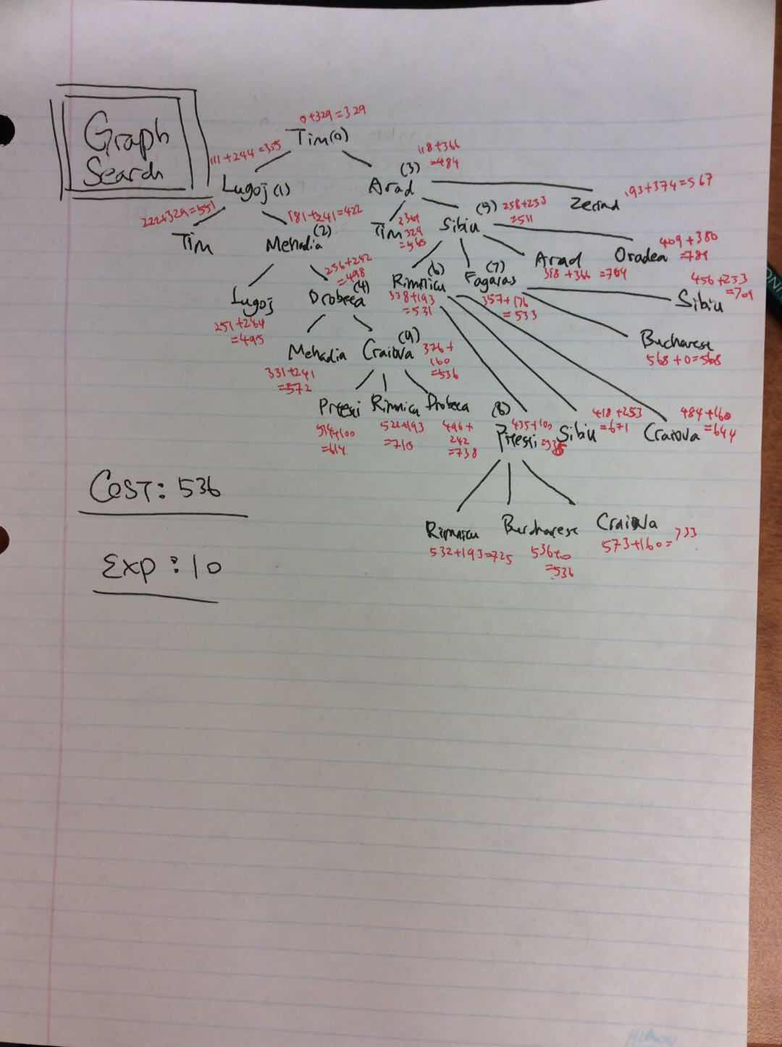

**Problem # 3**

TreeSearch----------------------------------

BreadthFirstTreeSearch: (cost=11.0, expansions=9505) 3 3 1 0 0 0 2 2 0 1 1 1 2 3 1 1 0 0 0 3 0 3 0 1 1 3 1 2 0 0 1 1 0 2 2 1 2 2 1 1 1 0 2 0 0 1 3 1 3 0 1 0 3 0 1 0 0 2 3 1 1 1 1 2 2 0 0 0 0 3 3 1

UniformCostTreeSearch: (cost=11.0, expansions=9595) 3 3 1 0 0 0 2 2 0 1 1 1 2 3 1 1 0 0 0 3 0 3 0 1 1 3 1 2 0 0 1 1 0 2 2 1 2 2 1 1 1 0 2 0 0 1 3 1 3 0 1 0 3 0 1 0 0 2 3 1 1 1 1 2 2 0 0 0 0 3 3 1

DepthFirstTreeSearch: (cost=203.0, expansions=203) 3 3 1 0 0 0 2 3 0 1 0 1 3 3 1 0 0 0 2 3 0 1 0 1 3 3 1 0 0 0 2 2 0 1 1 1 3 3 1 0 0 0 1 3 0 2 0 1 2 3 1 1 0 0 2 2 0 1 1 1 2 3 1 1 0 0 2 2 0 1 1 1 3 3 1 0 0 0 2 3 0 1 0 1 3 3 1 0 0 0 2 2 0 1 1 1 2 3 1 1 0 0 2 2 0 1 1 1 2 3 1 1 0 0 2 2 0 1 1 1 3 3 1 0 0 0 2 2 0 1 1 1 3 3 1 0 0 0 1 3 0 2 0 1 2 3 1 1 0 0 0 3 0 3 0 1 2 3 1 1 0 0 2 2 0 1 1 1 2 3 1 1 0 0 2 2 0 1 1 1 2 3 1 1 0 0 0 3 0 3 0 1 1 3 1 2 0 0 0 3 0 3 0 1 1 3 1 2 0 0 0 3 0 3 0 1 2 3 1 1 0 0 2 2 0 1 1 1 3 3 1 0 0 0 2 2 0 1 1 1 3 3 1 0 0 0 1 3 0 2 0 1 2 3 1 1 0 0 1 3 0 2 0 1 2 3 1 1 0 0 0 3 0 3 0 1 2 3 1 1 0 0 1 3 0 2 0 1 2 3 1 1 0 0 1 3 0 2 0 1 3 3 1 0 0 0 2 2 0 1 1 1 2 3 1 1 0 0 2 2 0 1 1 1 3 3 1 0 0 0 2 3 0 1 0 1 3 3 1 0 0 0 2 3 0 1 0 1 3 3 1 0 0 0 2 2 0 1 1 1 2 3 1 1 0 0 1 3 0 2 0 1 2 3 1 1 0 0 2 2 0 1 1 1 2 3 1 1 0 0 0 3 0 3 0 1 1 3 1 2 0 0 1 1 0 2 2 1 2 2 1 1 1 0 1 1 0 2 2 1 1 3 1 2 0 0 1 1 0 2 2 1 2 2 1 1 1 0 2 0 0 1 3 1 2 2 1 1 1 0 2 0 0 1 3 1 2 2 1 1 1 0 1 1 0 2 2 1 1 3 1 2 0 0 1 1 0 2 2 1 2 2 1 1 1 0 2 0 0 1 3 1 2 2 1 1 1 0 1 1 0 2 2 1 1 3 1 2 0 0 0 3 0 3 0 1 2 3 1 1 0 0 1 3 0 2 0 1 3 3 1 0 0 0 1 3 0 2 0 1 3 3 1 0 0 0 2 2 0 1 1 1 2 3 1 1 0 0 0 3 0 3 0 1 1 3 1 2 0 0 0 3 0 3 0 1 2 3 1 1 0 0 2 2 0 1 1 1 2 3 1 1 0 0 1 3 0 2 0 1 2 3 1 1 0 0 2 2 0 1 1 1 2 3 1 1 0 0 2 2 0 1 1 1 3 3 1 0 0 0 2 3 0 1 0 1 3 3 1 0 0 0 2 3 0 1 0 1 3 3 1 0 0 0 1 3 0 2 0 1 2 3 1 1 0 0 0 3 0 3 0 1 2 3 1 1 0 0 1 3 0 2 0 1 3 3 1 0 0 0 2 2 0 1 1 1 2 3 1 1 0 0 0 3 0 3 0 1 1 3 1 2 0 0 1 1 0 2 2 1 1 3 1 2 0 0 0 3 0 3 0 1 1 3 1 2 0 0 0 3 0 3 0 1 2 3 1 1 0 0 1 3 0 2 0 1 2 3 1 1 0 0 1 3 0 2 0 1 3 3 1 0 0 0 2 3 0 1 0 1 3 3 1 0 0 0 1 3 0 2 0 1 3 3 1 0 0 0 1 3 0 2 0 1 3 3 1 0 0 0 2 2 0 1 1 1 3 3 1 0 0 0 2 2 0 1 1 1 3 3 1 0 0 0 1 3 0 2 0 1 3 3 1 0 0 0 1 3 0 2 0 1 2 3 1 1 0 0 2 2 0 1 1 1 3 3 1 0 0 0 2 3 0 1 0 1 3 3 1 0 0 0 2 2 0 1 1 1 3 3 1 0 0 0 2 3 0 1 0 1 3 3 1 0 0 0 2 2 0 1 1 1 2 3 1 1 0 0 0 3 0 3 0 1 1 3 1 2 0 0 1 1 0 2 2 1 2 2 1 1 1 0 1 1 0 2 2 1 1 3 1 2 0 0 0 3 0 3 0 1 2 3 1 1 0 0 1 3 0 2 0 1 2 3 1 1 0 0 0 3 0 3 0 1 2 3 1 1 0 0 0 3 0 3 0 1 2 3 1 1 0 0 1 3 0 2 0 1 3 3 1 0 0 0 1 3 0 2 0 1 3 3 1 0 0 0 1 3 0 2 0 1 2 3 1 1 0 0 0 3 0 3 0 1 1 3 1 2 0 0 1 1 0 2 2 1 1 3 1 2 0 0 0 3 0 3 0 1 2 3 1 1 0 0 2 2 0 1 1 1 3 3 1 0 0 0 2 2 0 1 1 1 2 3 1 1 0 0 2 2 0 1 1 1 2 3 1 1 0 0 0 3 0 3 0 1 2 3 1 1 0 0 0 3 0 3 0 1 1 3 1 2 0 0 0 3 0 3 0 1 1 3 1 2 0 0 1 1 0 2 2 1 2 2 1 1 1 0 1 1 0 2 2 1 2 2 1 1 1 0 2 0 0 1 3 1 3 0 1 0 3 0 1 0 0 2 3 1 1 1 1 2 2 0 1 0 0 2 3 1 1 1 1 2 2 0 1 0 0 2 3 1 1 1 1 2 2 0 0 0 0 3 3 1

GreedyBestFirstTreeSearch: (cost=17.0, expansions=42) 3 3 1 0 0 0 2 2 0 1 1 1 2 3 1 1 0 0 0 3 0 3 0 1 1 3 1 2 0 0 1 1 0 2 2 1 1 3 1 2 0 0 0 3 0 3 0 1 1 3 1 2 0 0 0 3 0 3 0 1 1 3 1 2 0 0 1 1 0 2 2 1 2 2 1 1 1 0 2 0 0 1 3 1 3 0 1 0 3 0 1 0 0 2 3 1 1 1 1 2 2 0 0 0 0 3 3 1

DepthLimitedTreeSearch: null

IterativeDeepeningTreeSearch: (cost=11.0, expansions=3075) 3 3 1 0 0 0 1 3 0 2 0 1 2 3 1 1 0 0 0 3 0 3 0 1 1 3 1 2 0 0 1 1 0 2 2 1 2 2 1 1 1 0 2 0 0 1 3 1 3 0 1 0 3 0 1 0 0 2 3 1 2 0 1 1 3 0 0 0 0 3 3 1

GraphSearch----------------------------------

BreadthFirstGraphSearch: (cost=11.0, expansions=14) 3 3 1 0 0 0 1 3 0 2 0 1 2 3 1 1 0 0 0 3 0 3 0 1 1 3 1 2 0 0 1 1 0 2 2 1 2 2 1 1 1 0 2 0 0 1 3 1 3 0 1 0 3 0 1 0 0 2 3 1 2 0 1 1 3 0 0 0 0 3 3 1

UniformCostGraphSearch: (cost=11.0, expansions=14) 3 3 1 0 0 0 1 3 0 2 0 1 2 3 1 1 0 0 0 3 0 3 0 1 1 3 1 2 0 0 1 1 0 2 2 1 2 2 1 1 1 0 2 0 0 1 3 1 3 0 1 0 3 0 1 0 0 2 3 1 2 0 1 1 3 0 0 0 0 3 3 1

DepthFirstGraphSearch: (cost=11.0, expansions=12) 3 3 1 0 0 0 1 3 0 2 0 1 2 3 1 1 0 0 0 3 0 3 0 1 1 3 1 2 0 0 1 1 0 2 2 1 2 2 1 1 1 0 2 0 0 1 3 1 3 0 1 0 3 0 1 0 0 2 3 1 1 1 1 2 2 0 0 0 0 3 3 1

GreedyBestFirstGraphSearch: (cost=11.0, expansions=13) 3 3 1 0 0 0 2 2 0 1 1 1 2 3 1 1 0 0 0 3 0 3 0 1 1 3 1 2 0 0 1 1 0 2 2 1 2 2 1 1 1 0 2 0 0 1 3 1 3 0 1 0 3 0 1 0 0 2 3 1 1 1 1 2 2 0 0 0 0 3 3 1

DepthLimitedGraphSearch: null

IterativeDeepeningGraphSearch: (cost=11.0, expansions=12) 3 3 1 0 0 0 2 2 0 1 1 1 2 3 1 1 0 0 0 3 0 3 0 1 1 3 1 2 0 0 1 1 0 2 2 1 2 2 1 1 1 0 2 0 0 1 3 1 3 0 1 0 3 0 1 0 0 2 3 1 1 1 1 2 2 0 0 0 0 3 3 1

**Problem # 4**

TreeSearch----------------------------------

BreadthFirstTreeSearch: (cost=23.0, expansions=45) 0 0 0 12 0 0 9 0 3 1 8 3

UniformCostTreeSearch: (cost=23.0, expansions=685) 0 0 0 12 0 0 9 0 3 1 8 3

DepthFirstTreeSearch: (cost=307.0, expansions=57) 0 0 0 0 0 3 0 8 3 0 0 3 0 0 0 12 0 0 0 0 0 0 0 3 3 0 0 3 0 3 6 0 0 6 0 3 6 8 3 9 8 0 9 8 3 9 0 3 9 0 0 9 0 3 9 8 3 9 0 3 9 3 0 9 0 3 9 8 3 9 8 0 6 8 3 9 8 0 6 8 3 6 0 3 6 3 0 3 3 3 3 6 0 0 6 3 12 6 3 12 6 0 12 6 3 0 6 3 0 6 0 12 6 0 0 6 0 0 3 3 12 3 3 12 3 0 12 3 3 12 3 0 12 0 3 12 0 0 0 0 0 0 0 3 0 0 0 12 0 0 12 8 0 12 8 3 12 0 3 12 3 0 12 0 3 4 8 3 4 8 0 1 8 3

GreedyBestFirstTreeSearch: (cost=108.0, expansions=49) 0 0 0 0 0 3 12 0 3 12 8 3 12 0 3 12 3 0 12 3 3 12 6 0 9 6 3 9 6 0 6 6 3 9 6 0 9 6 3 12 6 0 9 6 3 9 6 0 9 6 3 12 6 0 12 3 3 0 3 3 3 3 0 3 0 3 6 0 0 6 0 3 9 0 0 1 8 0

DepthLimitedTreeSearch: (cost=29.0, expansions=5) 0 0 0 0 0 3 12 0 3 12 0 0 9 0 3 1 8 3

IterativeDeepeningTreeSearch: (cost=23.0, expansions=16) 0 0 0 12 0 0 4 8 0 1 8 3

AStarTreeSearch: (cost=23.0, expansions=663) 0 0 0 12 0 0 4 8 0 1 8 3

GraphSearch----------------------------------

BreadthFirstGraphSearch: (cost=23.0, expansions=19) 0 0 0 12 0 0 9 0 3 1 8 3

UniformCostGraphSearch: (cost=23.0, expansions=54) 0 0 0 12 0 0 9 0 3 1 8 3

DepthFirstGraphSearch: (cost=129.0, expansions=24) 0 0 0 0 0 3 12 0 3 12 8 3 0 8 3 3 8 0 3 8 3 3 0 3 3 3 0 0 3 3 0 3 0 12 3 0 9 3 3 9 3 0 9 0 3 9 8 3 12 8 0 12 0 0 4 8 0 4 8 3 4 0 3 4 3 0 4 3 3 4 6 0 1 6 3

GreedyBestFirstGraphSearch: (cost=45.0, expansions=13) 0 0 0 0 8 0 0 8 3 12 8 3 12 8 0 9 8 3 9 0 3 1 8 3

DepthLimitedGraphSearch: (cost=42.0, expansions=7) 0 0 0 0 8 0 12 8 0 9 8 3 9 0 3 9 0 0 1 8 0

IterativeDeepeningGraphSearch: (cost=23.0, expansions=8) 0 0 0 12 0 0 9 0 3 1 8 3

AStarGraphSearch: (cost=23.0, expansions=55) 0 0 0 12 0 0 9 0 3 1 8 3

**Problem # 5**

**Depth 4**

AStarTreeSearch: (cost=11.0, expansions=544) 3 3 1 0 0 0 1 3 0 2 0 1 2 3 1 1 0 0 0 3 0 3 0 1 1 3 1 2 0 0 1 1 0 2 2 1 2 2 1 1 1 0 2 0 0 1 3 1 3 0 1 0 3 0 1 0 0 2 3 1 2 0 1 1 3 0 0 0 0 3 3 1

AStarGraphSearch: (cost=11.0, expansions=13) 3 3 1 0 0 0 2 2 0 1 1 1 2 3 1 1 0 0 0 3 0 3 0 1 1 3 1 2 0 0 1 1 0 2 2 1 2 2 1 1 1 0 2 0 0 1 3 1 3 0 1 0 3 0 1 0 0 2 3 1 2 0 1 1 3 0 0 0 0 3 3 1

**Depth 5**

AStarTreeSearch: (cost=11.0, expansions=544) 3 3 1 0 0 0 1 3 0 2 0 1 2 3 1 1 0 0 0 3 0 3 0 1 1 3 1 2 0 0 1 1 0 2 2 1 2 2 1 1 1 0 2 0 0 1 3 1 3 0 1 0 3 0 1 0 0 2 3 1 2 0 1 1 3 0 0 0 0 3 3 1

AStarGraphSearch: (cost=11.0, expansions=13) 3 3 1 0 0 0 2 2 0 1 1 1 2 3 1 1 0 0 0 3 0 3 0 1 1 3 1 2 0 0 1 1 0 2 2 1 2 2 1 1 1 0 2 0 0 1 3 1 3 0 1 0 3 0 1 0 0 2 3 1 2 0 1 1 3 0 0 0 0 3 3 1

**Depth 6**

AStarTreeSearch: (cost=11.0, expansions=544) 3 3 1 0 0 0 1 3 0 2 0 1 2 3 1 1 0 0 0 3 0 3 0 1 1 3 1 2 0 0 1 1 0 2 2 1 2 2 1 1 1 0 2 0 0 1 3 1 3 0 1 0 3 0 1 0 0 2 3 1 2 0 1 1 3 0 0 0 0 3 3 1

AStarGraphSearch: (cost=11.0, expansions=13) 3 3 1 0 0 0 2 2 0 1 1 1 2 3 1 1 0 0 0 3 0 3 0 1 1 3 1 2 0 0 1 1 0 2 2 1 2 2 1 1 1 0 2 0 0 1 3 1 3 0 1 0 3 0 1 0 0 2 3 1 2 0 1 1 3 0 0 0 0 3 3 1